Name: Majid Ali
CMS: 053-25-0017
Section: Software engineering
Course: Networking (Lab2)
Week 2 Lab - To Construct Network Cables and Setup a LAN using networking tools and equipment
Objective:
a) To familiarize with different types of ethernet cables and connectors
b) To make straight-through and cross-over cables
c) To construct a LAN using those cables Components and Equipment Used
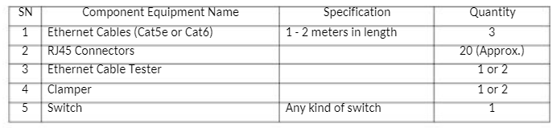

Ethernet cables can be wired as straight through or crossover. The straight-through is the most common type and is used to connect computers to hubs or switches. They are most likely what you will find when you go to your local computer store and buy a patch cable. Crossover Ethernet cable is more commonly used to connect a computer to a computer and may be a little harder to find since they aren't used nearly as much as a straight-through Ethernet cable. An RJ45 connector is a modular 8-position, the 8-pin connector used for terminating the Cat5e patch cable or Cat6 cable. A pinout is a specific arrangement of wires that dictate how the connector is terminated. Whether installing new cable, or troubleshooting existing cable, ethernet network cable testing plays an important role in the process. Network cable testing provides a level of assurance that the installed cabling links provide the desired transmission capability to support the data communication desired by the users. For testing, if the cable we created is as per the standard, we need a network cable tester.
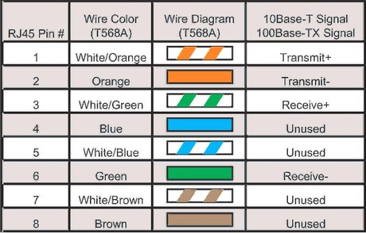
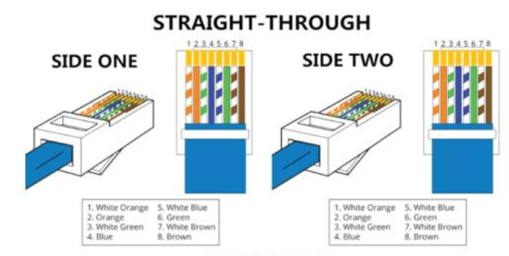
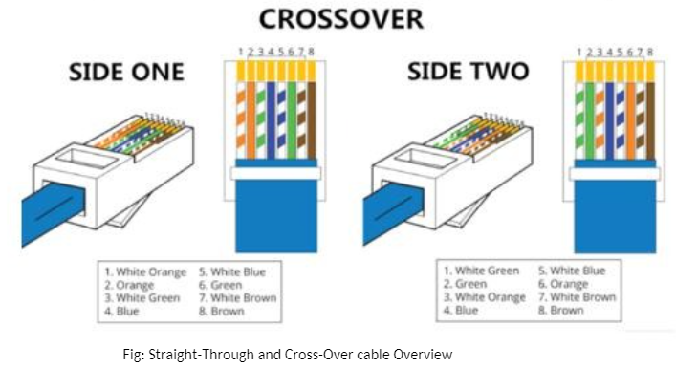
LAN setup: A star topology is a topology for a Local Area Network (LAN) in which all nodes are individually connected to a central connection point, like a hub or a switch. A star takes more cable than e.g. a bus, but the benefit is that if a cable fails, only one node will be brought down
All traffic emanates from the hub of the star. The central site is in control of all the nodes attached to it. The central hub is usually a fast, self-contained computer and is responsible for routing all traffic to other nodes. The main advantage of a star network is that one malfunctioning node does not affect the rest of the network. However, this type of network can be prone to bottleneck and failure problems at the central site.
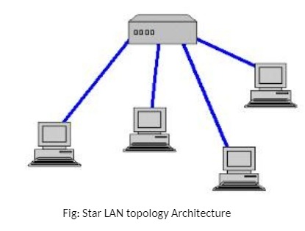
Procedure For creating Ethernet Cable: 1.Strip the cablejacket about 1.5 inches down from the end using Clamper's rolling blade. 2.Spread the four pairs of twisted wire apart. For cat6 you also need to cut the middle spine made up of plastic. 3.Untwist the wire pairs and neatly align them as per the standard as shown in the above figure. 4.Cut the wires as straight as possible, about 0.5 inches above the end of the jacket. 5.Carefully insert the wires all the way into the modular connector, making sure that each wire passes through the appropriate guides inside the connector. 6.Push the connector inside the crimping tool and squeeze the crimper all the way down. 7.Repeat steps 1-6 for the other end of the cable. 8.To make sure you've successfully terminated each end of the cable, use a cable tester to test each pin

Task: make Stright and cross cable connectors

Exercise
- What cable is used to connect only two hosts?
Answer:A crossover cable is used to directly connect two hosts. It allows both devices to communicate without a switch.

- What cable is connected between a switch and a host?
Answer: A straight-through cable is used to connect a switch and a host. It is commonly used for PC-to-switch connections.

- What cable is used to connect two routers?
Answer: A crossover cable is used to connect two routers through Ethernet ports. It allows direct communication between the routers.

- What cable is used to connect a router with a laptop to configure the router
Answer: A console cable is used to connect a router to a laptop. It allows the router to be configured through the console port.

- How many ports do the switch have that you see in the lab?
Answer: The switch used in the lab has 24 Ethernet ports. These ports are used to connect computers and other network devices.

- What types of ports do the switch have that you see in the lab?
Answer: The switch has Ethernet ports for connecting network devices and a console port for configuration. The Ethernet ports may support Fast Ethernet or Gigabit Ethernet
Disclaimer: The lab guide/instructions/manual has been compiled by taking help/content from various textbooks and public Internet resources for educational purposes.

